**SOFTWARE REQUIREMENT SPECIFICATION**

**DOCUMENT**

**SIMPLE CALCULATOR SYSTEM**

**Version:** Version 1.4

**ABSTRACT**

This document is intended to be the SRS for develop **SIMPLE CALCULATOR SYSTEM**

|  |  |  |  |
| --- | --- | --- | --- |
| **Project Title** | **SIMPLE CALCULATOR SYSTEM** | | |
| **Lead Institution** | **INTERNATIONAL SCHOOL - DUY TAN UNIVERSITY** | | |
| **Project Mentor** | **Mr. Nguyen Dang Quang Huy** | | |
| **Team Name** | **Team 4** | | |
| **Team Members** | **Thanh Tran Nguyen Duy** | | |
| **Thien Nguyen Ngoc** | | |
| **Huy Van Viet Bao** | | |
| **Khang Tran Quoc** | | |
| **Dinh Dang Quoc** | | |
| **Start Date** | Jan 25 , 2024 | **End Date** | Feb 18, 2024 |

**ROPRIETARY INFORMATION**: The information contained in this document is the property of **TEAM 4**. Except as specifically authorized in writing by **TEAM 4**, the holder of this document shall keep all information contained herein confidential and shall protect same in whole or in part from disclosure and dissemination to all third parties

**Table of Contents**

Revision History 5

1. Introduction 5

1.1. Purpose 5

1.2. Intended Audience and Reading Suggestions 5

1.3. References 5

2. Project Overview 5

2.1. Project Description 5

2.2. Business Need 6

2.3. Project Analyst 6

2.3.1. Business Function Diagram 6

2.3.2. System Context Diagram 7

2.4. Software Requirement Specification 8

2.4.1. High level Fucntional Requirement (FR) 8

2.4.2. Stakeholders 9

2.4.3. Usecase 10

2.4.4. List of use cases 10

2.4.5. Use Case Specification 10

*UC 02: Addition* 10

*UC 03: Subtraction* 12

*UC 04: Multiplication* 14

*UC 05: Division* 16

*UC 06: Remainder* 18

2.4.6. Activity Diagram 20

Appendix A: Glossary 24

# Revision History

|  |  |  |  |  |
| --- | --- | --- | --- | --- |
| **Date** | **Change Iterm** | **Description** | **by** | **Version** |
| **25/1/2024** | Work division | Team members meet and divide specific work | Thanh Tran Nguyen Duy | Version 1.0 |
| **28/1/2024** | BFD | Create a BFD | Thanh Tran Nguyen Duy  Khang Tran Quoc | Version 1.1 |
| **28/1/2024** | Complete Use case Diagram, Use case Specification | Draw Use case Diagram, Use case Specification | Thanh Tran Nguyen Duy | Verison 1.2 |
| **30/1/2024** | System Context Diagram, Activity Diagram | Draw System Context Diagram, Activity Diagram | Khang Tran Quoc | Verison 1.3 |

# Introduction

## Purpose

This document describes a simple computer system including the necessary information and functions used. The purpose of this document is as follows:

• Support project managers to have an overview of the system as well as prepare project estimates

• To describe the calculators and use cases in detail. Based on this documentation, analysts and designers will be able to implement the system easily.

• Assist testers (QC) in writing acceptance tests, calculations and test plans.

## Intended Audience and Reading Suggestions

|  |  |
| --- | --- |
| Intended Audience | Reading Suggestions |
| Project manager | High level functional requirement, business constraints for estimation |
| Architect analyst and designer | Overall description and use cases for system calculations and design |
| Quality control | Overall description and user cases to make test plan and write acceptance test |
|  |  |

## References

# Project Overview

## Project Description

## Information Technology has revolutionized the life of human beings and has made lives easier by the various kinds of applications. In the light of the rapid changes with the use of Information Technology, there are many tools,technologies and systems that have been produced and invented.

## This project is concerned with developing a Library Management System for Duy Tan Library in order to make library management more efficient and easy to handle. The Library management system enables a fully automated library service. The goals of this project are to provide simplicity as well as security and efficiency to the management of Duy Tan Library and also reduce managing personnel in the library.

## Business Need

This system had a number of advantages:

- Support librarians in professional tasks such as book management, managing readers faster and more efficiently.

- Support the work of searching for books to quickly access operations for readers.

- The program has all the requirements from the Duy Tan library, has the ability to maintain and upgrade.

- Easy-to-use interface.

## Project Analyst

### Business Function Diagram

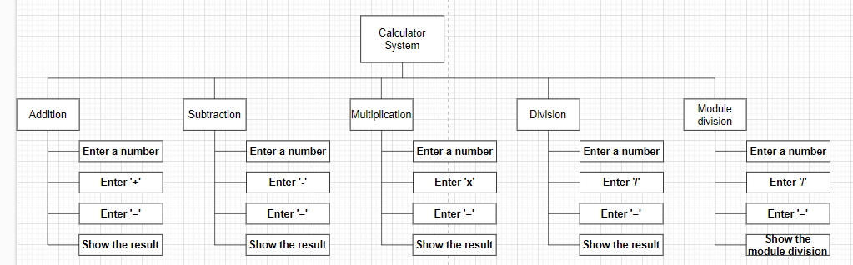

### System Context Diagram

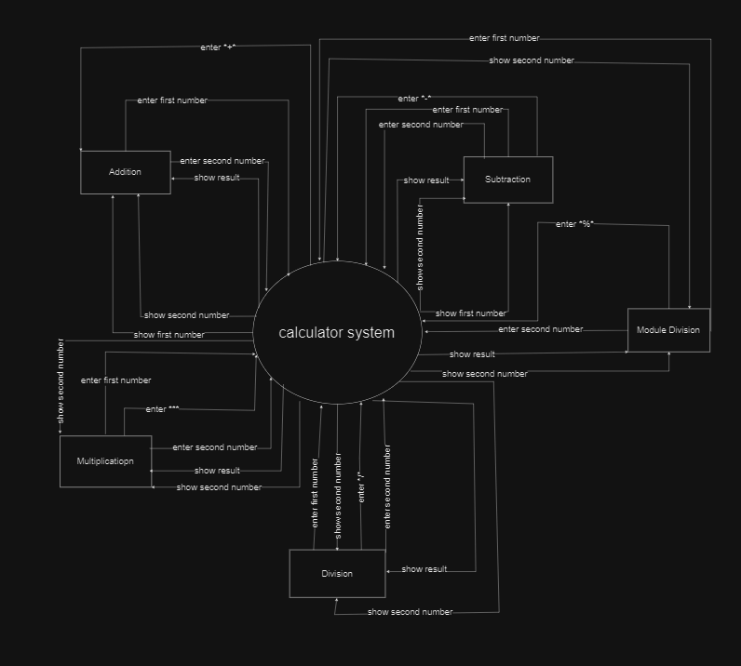

## Software Requirement Specification

### High level Functional Requirement (FR)

|  |  |  |
| --- | --- | --- |
| FR1.1 | Title | **Log in** |
|  | Actor | Actor who log in to the calculator to use its functions |
| Description | The user enters the registered username and password to access the calculator functions |
| FR1.2 | Title | **Addition** |
|  | Actor | Actor who use a calculator to calculate the sum of two any integers. |
|  | Description | The user will press the "Start" button on the device, then enter the first integer, '+' sign and the second integer. The calculator will calculate the sum of the two numbers entered and display the result on the screen. Users can use this result to calculate with other numbers |
| FR1.3 | Title | **Subtraction** |
|  | Actor | Actor who use a calculator to calculate the difference of two any integers. |
|  | Description | The user will press the "Start" button on the device, then enter the first integer, '-' sign and the second integer. The calculator will calculate the difference of the two numbers entered and display the result on the screen. Users can use this result to calculate with other numbers |
| FR1.4 | Title | **Multiplication** |
|  | Actor | Actor who use a calculator to calculate the product of two any integers. |
|  | Description | The user will press the "Start" button on the device, then enter the first integer, '*' sign and the second integer. The calculator will calculate the product of the two numbers entered and display the result on the screen. Users can use this result to calculate with other numbers |
| FR1.5 | Title | **Division** |
|  | Actor | Actor who use a calculator to calculate the quotient of two any integers. |
|  | Description | The user will press the "Start" button on the device, then enter the first integer, '/' sign and the second integer. The calculator will calculate the quotient of the two numbers entered and display the result on the screen. If the second number results in 0, the division will not be performed. Users can use this result to calculate with other numbers |
| FR1.6 | Title | **Remainder** |
|  | Actor | Actor who use a calculator to calculate the remainder of division of two any integers. |
|  | Description | The user will press the "Start" button on the device, then enter the first integer, '/' sign and the second integer. The calculator will calculate the remainder of the two numbers entered or fraction and display the result on the screen. If the second number results in 0, the division will not be performed. Users can use this result to calculate with other numbers |

### Stakeholders

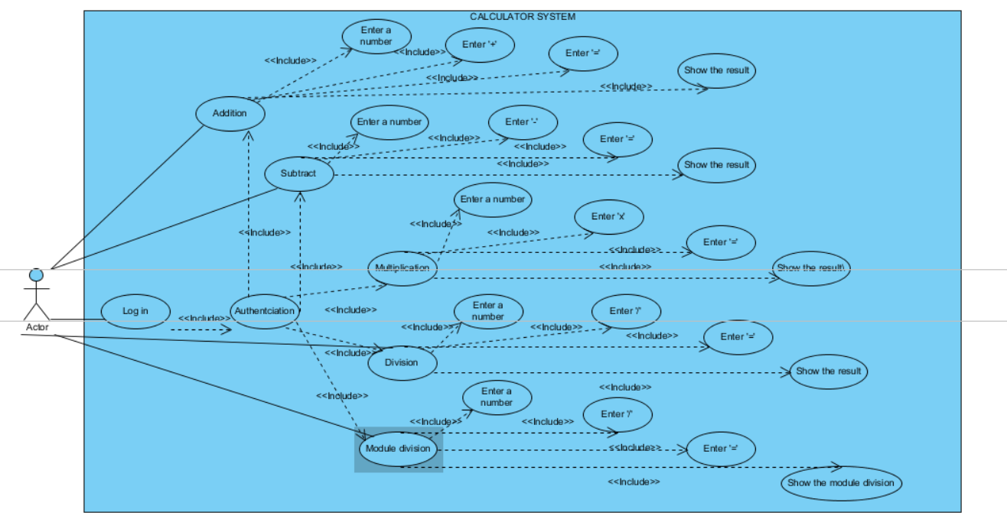

### Use case

|  |  |
| --- | --- |
| **Stakeholder** | **Description** |
| Users (Students, Teacher, ...) | System users |

### List of use case

|  |  |  |
| --- | --- | --- |
| **Use case ID** | **Use case name** | **Functional Requirements** |
| UC.01 | Login | FR1.1 |
| UC.02 | Addition | FR1.2 |
| UC.03 | Subtraction | FR1.3 |
| UC.04 | Multiplication | FR1.4 |
| UC.05 | Division | FR1.5 |
| UC.06 | Remainder | FR1.6 |

**2.4.5.Use Case Specification**

##### UC.02: Addition

1. Use Case Diagram

Users

1. Use Case Specification

|  |  |  |  |  |  |
| --- | --- | --- | --- | --- | --- |
| Use case ID | UC.02 | | | | |
| Use case name | Addition | | | | |
| Created by | Thanh Tran Nguyen Duy | | Last updated by | | Thanh Tran Nguyen Duy |
| Date created | 29 Jan, 2024 | | Date last updated | | 30 Jan, 2024 |
| Actor | User : The person use the calculator  Calculator: An electronic device can perform of calcualtions | | | | |
| Description | Allow the users perform the addition of any two integer numbers | | | | |
| Goal | Calculate the sum of any two integer numbers | | | | |
| Trigger | Users enter any two integer numbers into the calculator | | | | |
| Pre-condition | * The calculator is turned on and functioning ordinary * The users khows how to use the calculator’s addition functions * Any two integer numbers entered are valid numerical values | | | | |
| Post-condition | * The calculator displays the sum of any two integer numbers on the screen * The sum is calculated accurately * The user can use the result for further calculations or operations | | | | |
| Main Success Scenario | Step | Actor Action | | System Response | |
| 1 | Users enter any first number into the calculator | | Calcilator store and display the first number | |
| 2 | Users enter a '+' button to perform addition calculators | | Calculator display '+' | |
| 3 | Users enter any second number into the calculator | | Calculator store and display the second number | |
| 4 | Users enter a '=' button to calculate | | Calculator calculates the two stored integer numbers and displays the sum of the two any integer numbers on the screen | |
| Alternative Scenario | Step | Actor Action | | System Response | |
| 1 | Users enter an invalid value ( e.g character, blank space ) | | Display an error message indicating invalid input | |
| 2 | Users presses an '=' button but then breaks the calculation before it completes(e.g : Press AC, turn off the computer) | | Stop the calculation process and display want to "Interrupt" or "Change" | |
| Exception | Step | Actor Action | | System Response | |
| 1 | Users enters two any integer numbers that result in a sum exceeding the calculator's maximum | | Displays an overflow error message. | |

##### UC.03: Subtraction

1. Use Case diagram

Users

1. Use Case Specification



##### UC.04: Multilplication

1. Use Case diagram

Users

1. Use Case Specification



##### UC.05: Division

1. Use Case diagram

Users

1. Use Case Specification



##### UC.06: Remainder

1. Use Case diagram

Users

1. Use Case Specification



## 2.4.6 . Activity Diagrams

Addition

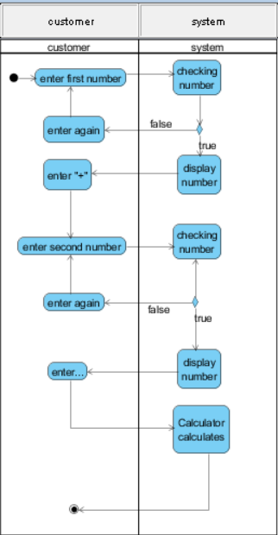

Subtraction

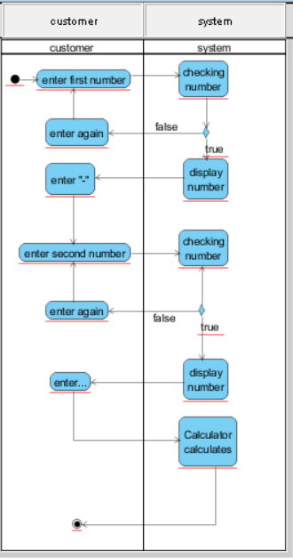

Multiplication

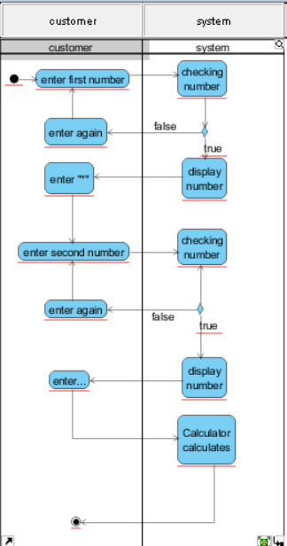

Division

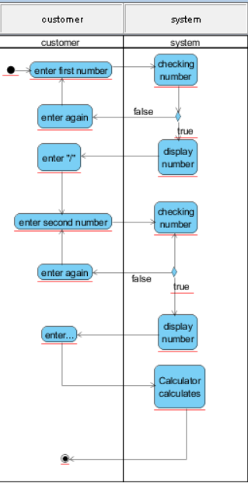

Remainder

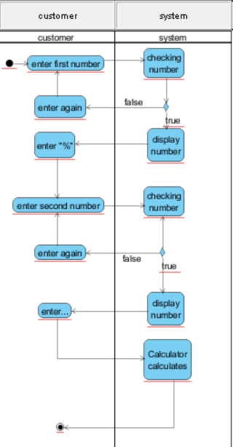

# Appendix A: Glossary

|  |  |
| --- | --- |
| FR | Functional Requirement |
| QA | Quality Attribute |
| UC | Use case |
| BR | Business rule |